**Bitcoin Stock-To-Flow Model**

**Bitcoin:**

The bitcoin is decentralized digital or virtual currency that uses peer-to-peer technology to facilitate payment. It was created in 2009, and it has since then grown to be one of the most expensive and stable digital currency.

**Stock-to-Flow model:**

In simple terms, the Stock to Flow (SF or S2F) model is a way to measure the abundance of a particular resource. The Stock to Flow ratio is the amount of a resource held in reserves divided by the amount it is produced annually. The Stock to Flow model is generally applied to natural resources.

**Bitcoin Stock-to-Flow model:**

The Stock-to-Flow model is a model that was made popular by a Dutch institutional investor under the pseudonym ‘Plan B’. Low rate of supply, which PlanB defines as “scarcity,” can be quantified using a metric called Stock-to-Flow (SF).

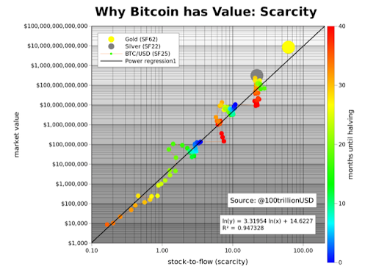This notion now breeds into the hypothesis that, “…that scarcity, as measured by SF, directly drives value.” The figure below shows the bitcoin’s SF against USD market capitalization as well as two arbitrarily chosen SF data points for gold and silver.

Figure 1. Taken from "Modeling Bitcoin Value with Scarcity," by PlanB.(*coindesk.com)*

This model treats Bitcoin as being comparable to commodities such as gold, silver or platinum. These are known as 'store of value' commodities because they retain value over long time frames due to their relative scarcity. Bitcoin is similar, it is also scarce. In fact, it is the first-ever scarce digital object to exist.

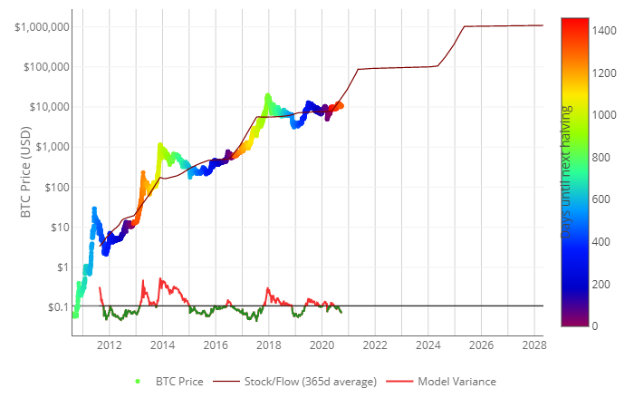

Figure 2. The chart Bitcoin prices over the year and S2F model *(source: Lookintobitcoin.com)*

**Why is the model is a bad idea for Bitcoin**

It is a model that was drafted based on assumptions and inference from the model utilized on gold, silver and other tangible assets.

1. From a theoretical point of view, the model is based on the rather strong assertion that the USD market capitalization of a monetary good (e.g. gold and silver) is derived directly from their rate of new supply. No evidence or research is provided to support this idea, other than the singular data points selected to chart gold and silver’s market capitalization against bitcoin’s trajectory.
2. Emergence of new coins:

The same way Bitcoin is thriving, a lot of newly emerging coins are also thriving, they also pose a competition for the most ‘*bullish’*. Though as at now Bitcoin is the most bullish, but the situation might change in the next few years, which in turn affects the prediction.

1. International policies:

These are the policies that affect foreign exchange prices and intermittently will affect the digital currencies likewise.

1. Anonymity of traders:

The fact that the bitcoin transactions are usually untraceable can be a factor that will reduce the popularity index of using it as a means of transaction, inadvertently reducing the market cap and value. The lower the demand for a commodity, the lower the price of the commodity.

According the S2F model, it predicted that after the next halving (in May 2020) the market cap of Bitcoin was going to increase up-to $1,000,000,000,000 (One trillion). As at September 2020, the market cap totals at ~ $200 billion, barely a 20% of the predicted value.

These along with other reasons make the Stock-to-Flow model a bad idea for Bitcoin.